Stata commands for assignment 2

First things first: here is how to see what the variables are. Here is your Stata screen. Put the cursor on the edge of the “variables” box as shown and it will turn into an arrow.

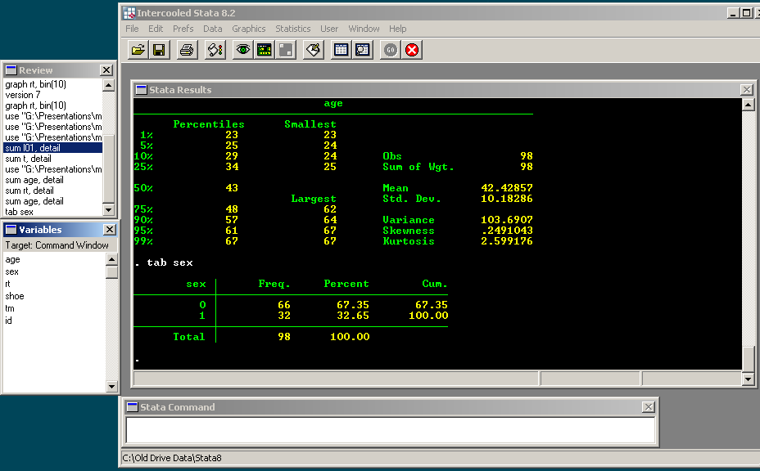

Then drag the edge of the box to the right.

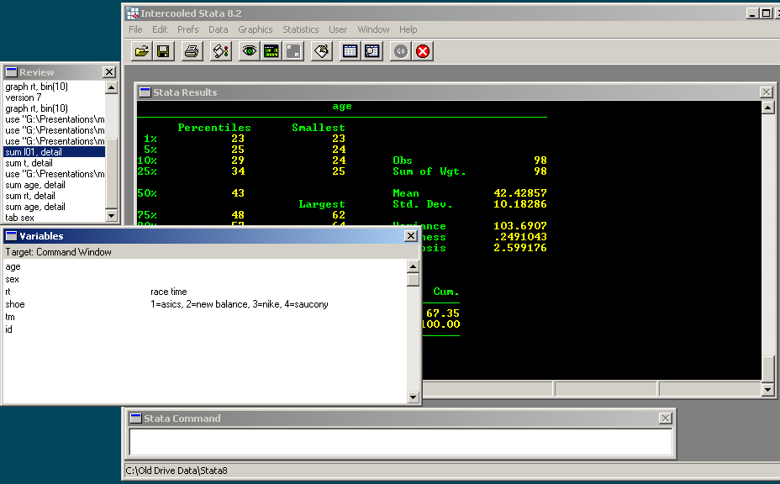

The commands you might think about using for the data sets sent after lecture 2 are given below. I give examples from 01a.dta, the data I sent after lecture 1.

Summarizing continuous variables

The basic command is "sum", short for summarize

For example, typing "sum age" gives you:

Variable | Obs | Mean | Std. Dev. | Min | Max
age | 386 | 49.48446 | 13.75466 | 19 | 86

So you can tell you have data on age for 386 patients ("obs" standards for "observations"), the mean age was 49 years, standard deviation of the mean was 13.8. The youngest patient was 19 and the oldest was 86

“sum age, detail” gives some additional information about the variable.

age
-------------------------------------------------------------
Percentiles Smallest
1% 21 19
5% 29 20
10% 31 21 Obs 386
25% 40 21 Sum of Wgt. 386

50% 49 Mean 49.48446
Largest Std. Dev. 13.75466
75% 59 82
90% 68 85 Variance 189.1907
95% 73 86 Skewness .1840914
99% 82 86 Kurtosis 2.559797

The stuff highlighted in yellow is the information from the basic "sum" command, the number of observations, the mean and the standard deviation. Ignore the stuff highlighted in blue (variance, skewness, kurtosis and "sum of wgt”), you don't need to know this. The four numbers under “smallest” (19, 20, 21, 21 in green) are the ages of the four youngest patients. The four numbers under “largest” (grey) are the ages of the four oldest patients. The numbers next to 25%, 95% etc. are the centiles. So the median is in pink (next to 50%), and the interquartile range is red to light blue (40, 59).

Centiles

You can get Stata to give you centiles directly by typing “centile age, c(25 50 75). This gives print out as

Variable | Obs | Percentile | Centile | [95% Conf. Interval]
age | 386 | 25 | 40 | 38 | 41.90643
 |  | 50 | 49 | 47 | 51
 |  | 75 | 59 | 57 | 61

The “percentile” column in blue says that you are looking at the 25th, 50th and 75th centile, i.e. the median and quartiles. The “centile” column in green gives you the actual values. So you could report this as “Median age was 49 (quartiles: 40 – 59). You aren’t restricted to the quartiles with the “centile” command. For example, you could type “centile age, c(11 45 78 91.5)” to give you the 11th, 45th and 78th centile, as well as 91.5 centile, which would be the 915th highest value in a dataset of 1000 obserations.
One way table

“tab sex”: gives a frequency table, in this case, the number of men and women.

1 if woman,
0 if man | Freq. | Percent | Cum.
0 | 181 | 46.89 | 46.89
1 | 205 | 53.11 | 100.00
Total | 386 | 100.00

So there are 181 (47%) women and 205 (53%) men.

Two-way tables

“tab sex y”: gives a table shows where operations were done (remember that the variable y gives the part of the hospital) in men and women separately

1 if woman, 0 if man | campus | harding | peds | satellite | Total
0 | 115 | 15 | 19 | 32 | 181
1 | 125 | 24 | 21 | 35 | 205
Total | 240 | 39 | 40 | 67 | 386

This shows that, for example, there were 240 operations done at the main campus, 115 of these were done on men and 125 on women.

“tab sex y, row”: includes percentage of men who had operations at each site and percentage of women who had operations at each site

1 if woman, 0 if man | campus | harding | peds | satellite | Total
0 | 115 | 15 | 19 | 32 | 181
 | 63.54 | 8.29 | 10.50 | 17.68 | 100.00
1 | 125 | 24 | 21 | 35 | 205
 | 60.98 | 11.71 | 10.24 | 17.07 | 100.00
Total | 240 | 39 | 40 | 67 | 386
 | 62.18 | 10.10 | 10.36 | 17.36 | 100.00

This shows that, for example, 8% of men and 12% of women had operations at the “Harding” site, and that, in total, 10% of operations were done at this site.

“tab sex y, col”: includes percentage of operations at each site that were for men and women

1 if woman, 0 if man | campus | harding | peds | satellite | Total
0 | 115 | 15 | 19 | 32 | 181
 | 47.92 | 38.46 | 47.50 | 47.76 | 46.89
1 | 125 | 24 | 21 | 35 | 205
 | 52.08 | 61.54 | 52.50 | 52.24 | 53.11
Total | 240 | 39 | 40 | 67 | 386
 | 100.00 | 100.00 | 100.00 | 100.00 | 100.00

This shows that 48% of the operations at the satellite were on men and 52% on women. Overall (look in the “total” column), 47% of the patients treated in the hospital were men and 53% women.

“tab y if sex==1” and “tab y if sex==0” gives the tables for men and women separately, along with percentages. Remember that you have to include two equal signs when using “if”.

You can get the same data from a table by using the “count” function.
“count” gives the number of observations in a data set
“count if sex==1”: gives the number of women in the data set (don’t forget that you need two equals signs after an “if” statement)
“count if sex ==1 & y== “campus” gives number of operations on women at the main campus

By the way, try typing “tab age” and see why continuous data are not summarized by tables!

Statistical test for normality

Typing “swilk age” gives you the following print out.

Shapiro-Wilk W test for normal data
Variable | Obs | W | V | z | Prob>z
age | 386 | 0.99332 | 1.781 | 1.371 | 0.08525

The p value is the last column “Prob>z”. Now we’ll discuss p values at some length later in the course. For now, note whether p is greater or less than 0.05. If it is, then you have to worry that the data are not normally distributed. Now I am actually very suspicious of this test, and rarely use it. But I’ve given you the code to help you think through a little bit more about what normal data means.

Graphing the data

We won’t be doing much on the graphical presentation of data in this course (this has been called “graphicacy”). The only reason we are doing it here is to get a visual impression of whether data are normally presented (not something you’d want to publish).

The following might sound a little complicated, but just follow it through and everything will be fine. To start, type “histogram age".

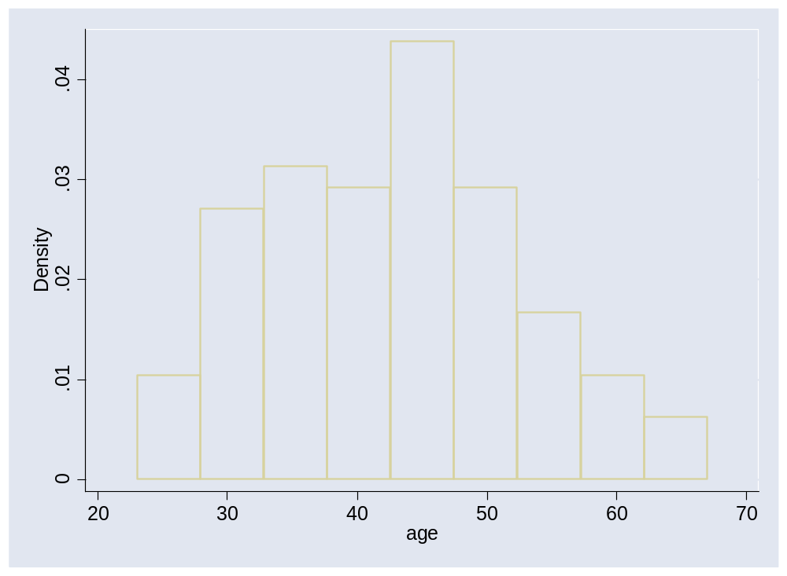

One of things that Stata does is to choose the number of bars for you. You can set this yourself by typing: “histogram age, bin(x)” where x is the number of bars. For example, "histogram age, bin(40)" gives you:

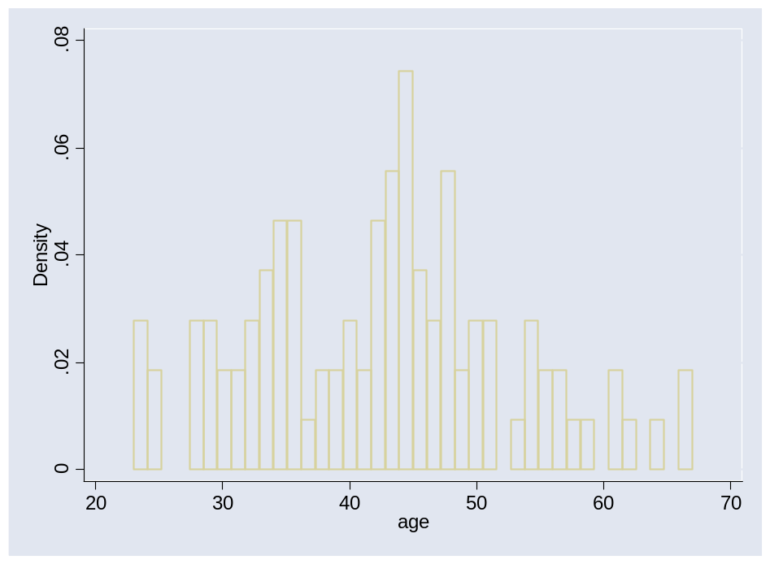
The graph looks “lumpy” because you are breaking the data up into too many small pieces.
“histogram, normal” superimposes a curve for the normal distribution.
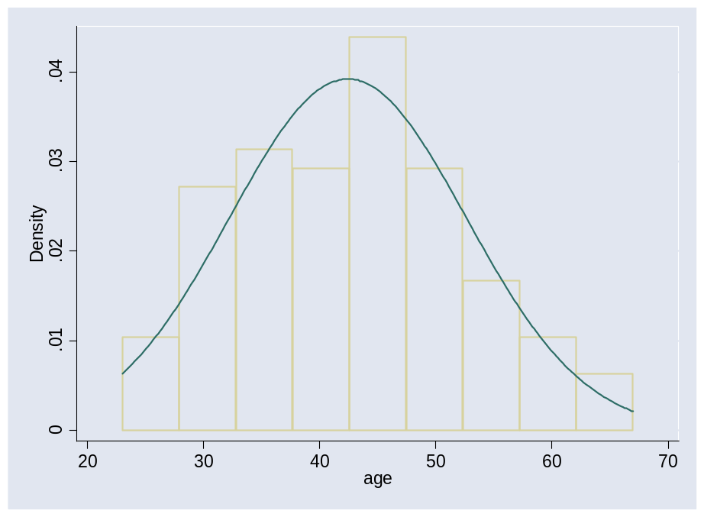

Only read this page if you are feeling really keen….

“ci age, level (90)”: ci gives the mean of age, its standard error and its 90% confidence interval (I’ll explain confidence intervals next week: one thing you might want to think about is to compare the two numbers given for the confidence interval with the 5% and 95% centile from “sum age”. )

Variable | Obs | Mean | Std. Err. | [90% Conf. | Interval]
age | 386 | 49.48446 | .7000938 | 48.33013 | 50.63879

“ci sex”: this gives the proportion of women along with 95% confidence intervals (95% is the default, meaning if you don’t specify a level, it assumes you want the 95% confidence interval.

Using Stata as a calculator

“disp 7*7”: gives the value “49” on screen
“disp log(2.71828)”: log is the natural logarithm (to base e)
“disp exp(1)”: exp is the inverse natural logarithm, that is, if exp(x)=y, e^{y}=x
“disp log10(100)” gives the log to base 10
“disp cos(45)” gives you the cosine of 45: there are many other functions you can use with “disp” and other commands (though you won't need to for this course). Use the help function: search for “functions”

Some of the functions give useful statistical constants. “normprob (x)” gives the probability that an observation will be less than mean + xstandard deviations. For example, “disp normprob (1)” gives 0.84. This means that 84% of a normally distributed set of data will be less than one standard deviation above the mean. “disp normprob (-0.5) gives 0.31, meaning that 31% of a normally distributed set of data will be less than half a standard deviation below the mean. So if you had a pain score with a mean of 5 and a standard deviation of 2, you could predict that only 16% of patients would have pain scores of 7 or more and that 70% would have pain scores of 4 or more.

“disp normprob (1.96)” gives 0.975 and “disp normprob (-1.96)” gives 0.025. So 97.5% of observations are less than 1.96 standard deviations greater than the mean, and 2.5% are less than 1.96 standard deviations lower than the mean. In other words, 95% of observations are within 1.96 standard deviations of the mean.

“clear”: dumps all data from memory and gives you a new spreadsheet to work with

